**QSMART – KEY CARD REPLACEMENT**

**PROCEDURE**

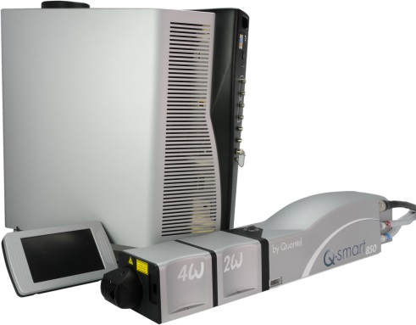

**Toolkit:**

Allen keys

**System** : QSMART

|  |  |  |  |  |  |  |  |  |  |  |
| --- | --- | --- | --- | --- | --- | --- | --- | --- | --- | --- |
| |  |  | | --- | --- | | 4/300/1077 | **Q-SMART KEY CCA** | | | | | |  |  |  |  |
|  |  |  |  |
|  |  |  |  |

**Purpose**: This document details how to change the key card

|  |  |  |
| --- | --- | --- |
| Revision | date | modification |
| Initial issue | July 4, 2014 |  |
|  |  |  |
|  |  |  |
|  |  |  |

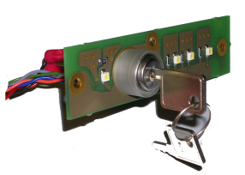

# DISASSEMBLING

* Unplug the system and disconnect all cables

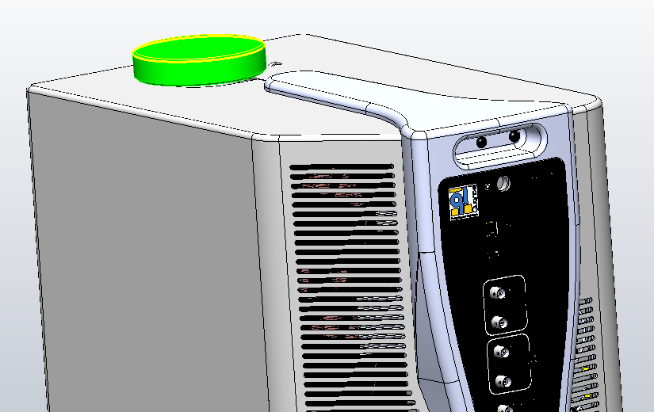

* Remove the CG cap

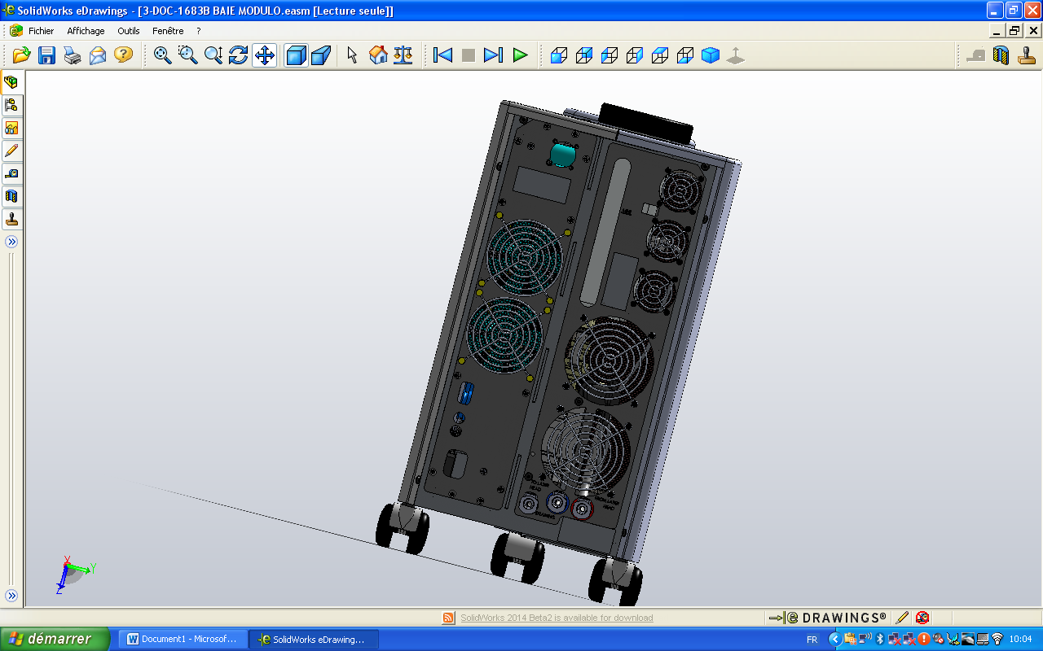

3/E13/0600

* Remove the 4 screws 3/E13/0600 (Rear panel)

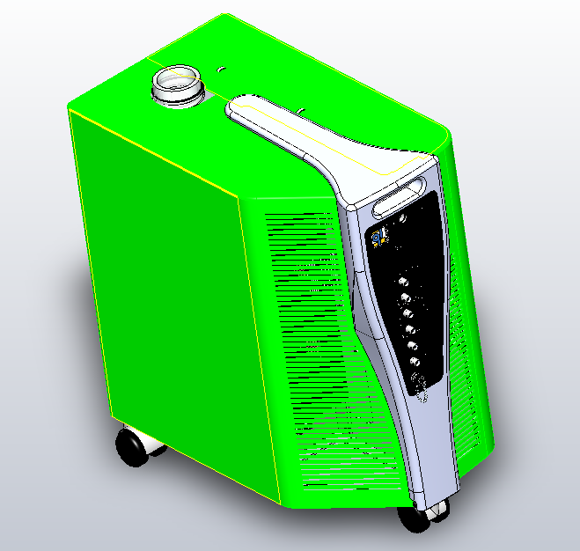

3/E13/0600

Enlever les 4 Vis 3/E13/0600 (face avant). Enlever les deux flasques 3/PNT/0511 et 3/PNT/0512

* Remove the 4 screws 3/E13/0600 (front). Remove the two side panels.

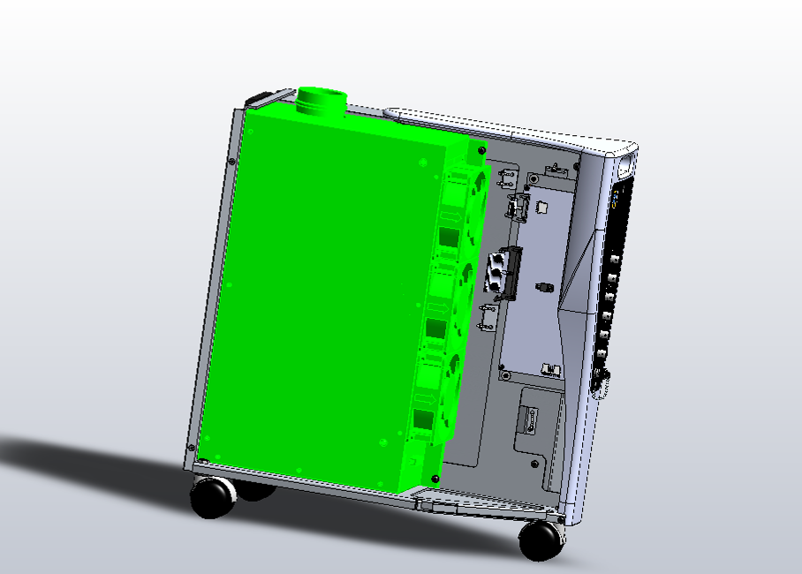

3/E13/0600

* Remove the CG (3 Black BHC 4x12 (3/E13/0600)).

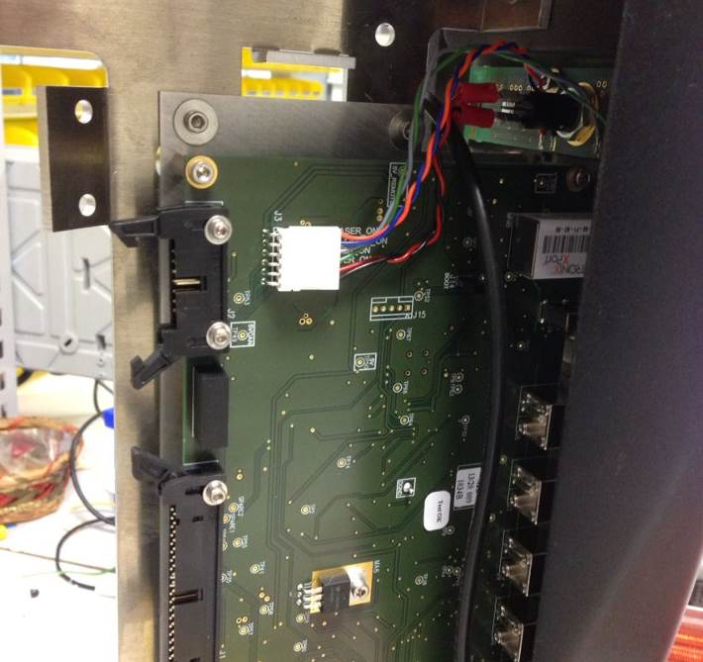

* Disconnect the key card from the CPU as pictured.
* Remove the front panel ICE.

BHC4x8

BHC 4x6+LLU4

BHC 4x8

BHC 4x8+LLU3

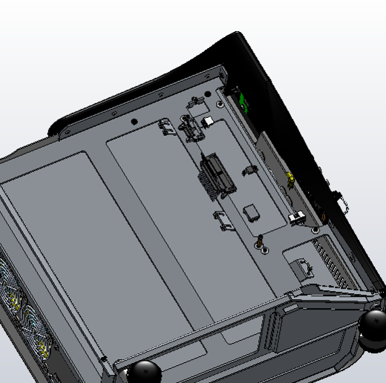

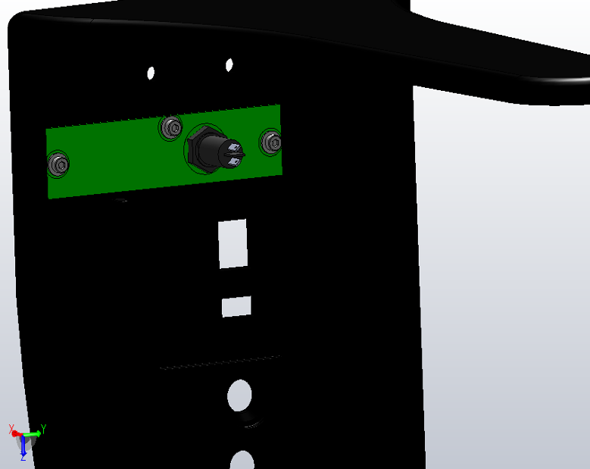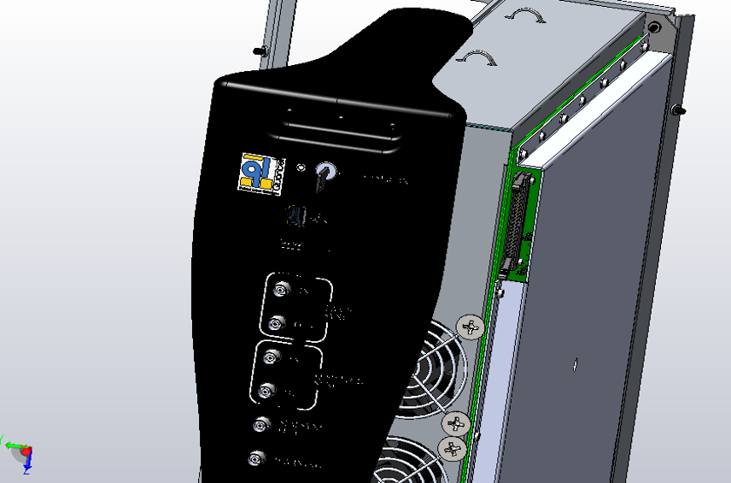

* Remove the key card 4/300/1077 (3 screws CHC 3x6 + 3 washers CS3).

CHC 3x6 + CS3

# KEY CARD INTEGRATION

|  |  |  |
| --- | --- | --- |
| 3.00 | V/CHC-M0306A4 | CHC 3x6 SCREW |
| 3.00 | R/CS--D03--ZB | CS3 WASHER |



CHC 3x6 + CS3

* Fasten the key card 4/300/1077 (3 CHC 3x6 +3 CS3).

Be careful to put the key in front of the 0 when tightening.

* Attach the ICE front panel.

|  |  |  |
| --- | --- | --- |
| 3.00 | V/BHC-M0406-A2 | BHC 4X6 SCREW |
| 4.00 | V/BHC-M0408-A2 | BHC 4X8 SCREW |
| 3.00 | R/LLU-D04--A2 | LLU4 WASHER |



BHC4x8

BHC 4x6+LLU4

BHC 4x8

BHC 4x8+LLU3





Connect the key card to the CPU as pictured.

# COVERING

|  |  |  |
| --- | --- | --- |
| 8.00 | 3/E13/0600 | BLACK BHC 4x12 SCREW |

Implement both side panels and fasten with 8 BHC Black 4x12 (3/E13/0600) screws



3/E13/0600



3/E13/0600

CAUTION: Leave a space between two covers

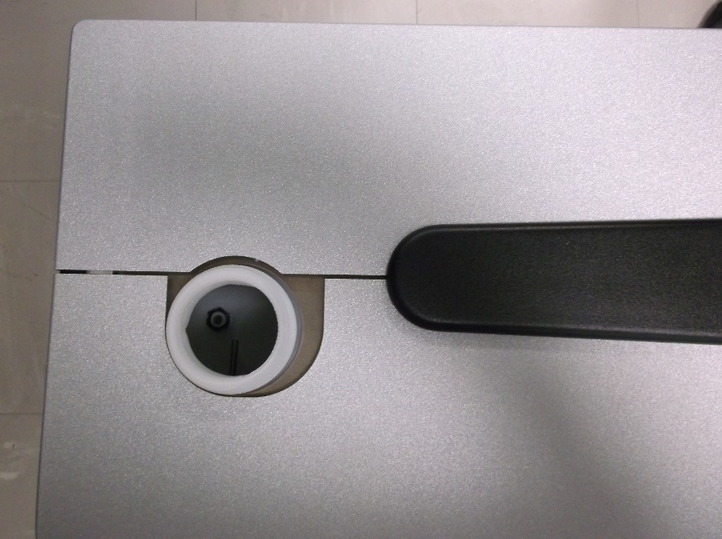



Put back in place the CG cap